**The IKM Java developer test results:**

**Level: Senior, Lead.**

**Java 8**

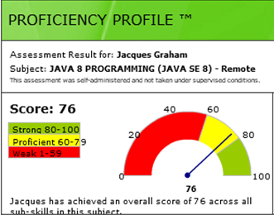

**Java 8, Spring**

